ORTHOPAEDIC INSTRUMENTS
Bone Levers & Retractors
Bone Lever for Femur–Tibia
Intended Use
The femur-tibia bone lever is an anatomically designed retraction instrument used to displace the femur or tibia away from surrounding soft tissue during plating, nailing or arthroplasty procedures in the canine and feline stifle region. It provides the unobstructed bone exposure required for safe implant application in large breed orthopaedic cases. | 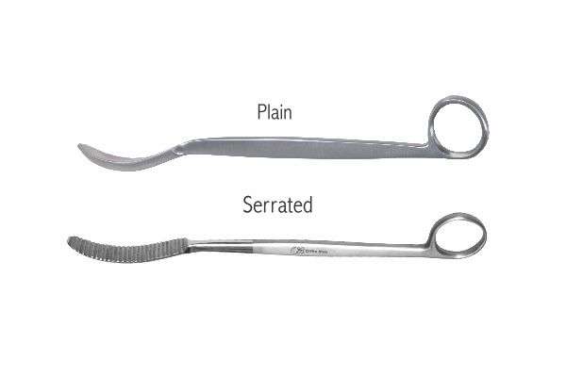
Function
The instrument's curved blade is introduced around the posterior or medial femoral or tibial cortex and levered against the bone, pushing surrounding hamstring or calf musculature posteriorly. The handle angle keeps the surgeon's hand out of the direct operative field while maintaining sustained bone exposure.
Advantages
Anatomy-Specific Curvature: The blade curvature matches the cross-sectional profile of the femoral and tibial diaphyses, allowing the lever to sit securely on the cortex without slipping during sustained retraction — preventing accidental instrument displacement that could injure the popliteal neurovascular bundle.
Unobstructed Plate Application: By displacing muscle masses away from the bone surface, the lever creates the exposure needed for accurate plate centring and screw insertion without having an assistant maintain manual retraction throughout.
FAQ
Q: Can the femur-tibia lever be used for intramedullary nailing?
A: Yes. The lever retracts soft tissue away from the nail entry point and along the nail insertion path, protecting the quadriceps mechanism and popliteal vessels during tibial IM nail placement.
Q: How is the lever positioned to avoid neurovascular injury?
A: Place the blade on the cortex surface and slide it subperiosteally before levering; never force the blade through soft tissue — pass it carefully around the bone under direct vision to avoid the popliteal artery and sciatic nerve.

ORTHOPAEDIC INSTRUMENTS
Bone Levers & Retractors
Bone Lever for Radius–Ulna
Intended Use
The radius-ulna bone lever is a slim-profile retraction instrument specifically designed to retract soft tissue from the narrow, interosseous space between the radius and ulna in small animal antebrachial surgery. It facilitates safe plating of radius and ulna fractures in dogs and cats by providing clear bone exposure in a confined anatomical region. | 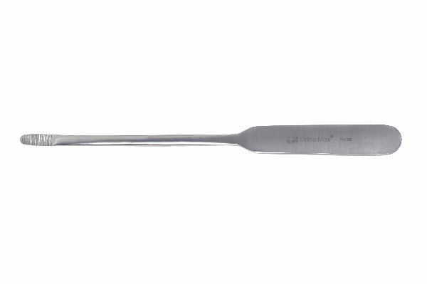
Function
The slim, curved blade profile is dimensioned to fit in the tight interosseous space between the paired forearm bones. The blade tip passes around the radius or ulna cortex and is levered gently, displacing the interosseous membrane and flexor muscles to provide surgical access to the full bone length for plate application.
Advantages
Narrow-Profile Interosseous Access: The slim blade dimensions allow access between the radius and ulna in small and toy breeds where large retractors simply cannot fit without causing iatrogenic injury to the interosseous membrane or digital flexor tendons.
Bilateral Bone Stabilisation: When levers are placed on both bones simultaneously, the radius and ulna are immobilised relative to each other, preventing the rotational instability that complicates antebrachial plate fixation when only one bone is held.
FAQ
Q: Is a dedicated R-U lever needed or can a Hohmann retractor be used?
A: The dedicated R-U lever's profile fits the specific geometry of the canine and feline antebrachium better than a standard Hohmann; using a larger Hohmann risks interosseous membrane damage in small dogs.
Q: Which bone is plated first when both radius and ulna are fractured?
A: The radius is stabilised first as it is the primary weight-bearing bone; the ulna is then reduced against the stabilised radius and plated or left to heal if alignment is restored by the radius plate.

ORTHOPAEDIC INSTRUMENTS
Bone Levers & Retractors
Czerny Retractor
Intended Use
The Czerny retractor is a double-ended handheld retractor used to retract skin and soft tissue in orthopaedic and general surgical approaches in veterinary patients. Its dual working ends of different sizes allow the instrument to serve as both a deep and superficial retractor without changing instruments. | 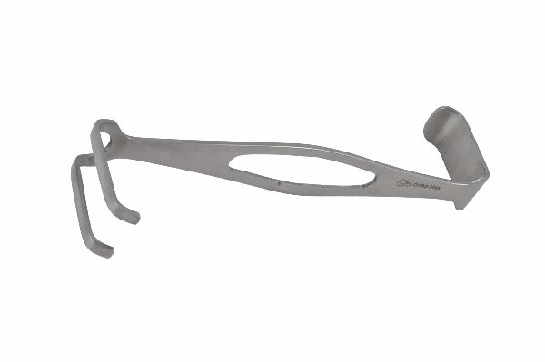
Function
A flat or slightly curved blade at each end of the handle retracts tissue when pulled against its face. The two ends differ in width and depth, allowing the same instrument to retract a wide shallow flap or a narrow deep wound. The smooth handle provides a secure non-slip grip for sustained manual retraction.
Advantages
Dual-Purpose Single Instrument: Two working ends of different geometry eliminate the need for separate shallow and deep retractors on the sterile tray, simplifying instrument setup and reducing the number of instruments requiring processing after surgery.
Smooth Blade Profile: Rounded, smooth blade edges minimise soft tissue trauma during retraction compared to sharp-raked retractors, reducing post-operative wound oedema and pain in small animal patients.
FAQ
Q: When is the Czerny retractor preferred over a self-retaining retractor?
A: In narrow wounds or when the tissue being retracted is too fragile for the fixed tines of a self-retaining device; manual retractors allow the assistant to modulate pressure dynamically as the anatomy changes.
Q: What approach types use the Czerny retractor?
A: Craniolateral stifle approaches, medial tibial approaches, lateral femoral approaches and standard dorsal laminectomy approaches in dogs and cats all routinely use Czerny-type retractors.

ORTHOPAEDIC INSTRUMENTS
Bone Levers & Retractors
Double Hook Skin Retractor
Intended Use
The double hook skin retractor is a manual retraction instrument used to retract skin and subcutaneous tissue at the wound margins during orthopaedic surgical approaches in veterinary patients. The paired hooks provide a firm grip on the skin edge, maintaining wound exposure without tearing fragile dermis. | 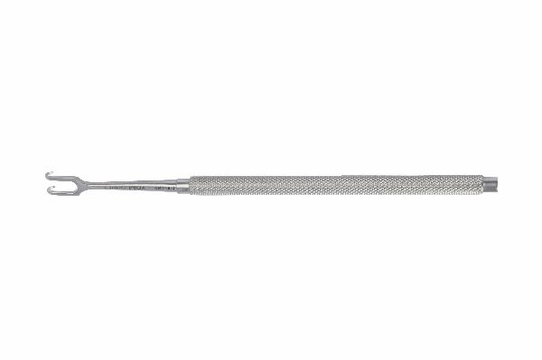
Function
Two sharp or blunt hooks are fixed to each end of the handle, engaging the dermal layer of the wound margin when pulled outward. The pair of hooks distributes the retraction force over two points, preventing the skin tearing that can occur with a single sharp hook under sustained retraction pressure.
Advantages
Secure Skin Edge Grip: The dual-hook configuration distributes traction force, reducing the point pressure that tears skin at the wound margin — a practical advantage in thin-skinned, elderly or malnourished patients where skin integrity is compromised.
Minimal Instrument Bulk: The slim hook design does not obstruct the surgeon's view or deep instruments the way wider retractors do, making the double hook an ideal first-layer retractor in combination with deep tissue retractors.
FAQ
Q: Sharp or blunt hooks — which to use?
A: Sharp hooks grip thicker skin more securely and are preferred in skin-only retraction; blunt hooks are safer near subcutaneous vessels and are used when skin is thin or when slippage onto deeper structures is a risk.
Q: How many hook retractors are typically used per wound?
A: Two retractors per wound margin are standard — one on each side — providing balanced bilateral retraction that keeps the wound opening symmetrical throughout the procedure.

ORTHOPAEDIC INSTRUMENTS
Bone Levers & Retractors
Hohmann Retractor
Intended Use
The Hohmann retractor is a single-blade lever-style retractor that is the workhorse soft tissue retractor in veterinary orthopaedic surgery. It is used to displace muscle, periosteum and capsule away from bone during fracture fixation, arthroplasty and osteotomy approaches across virtually all anatomical regions. | 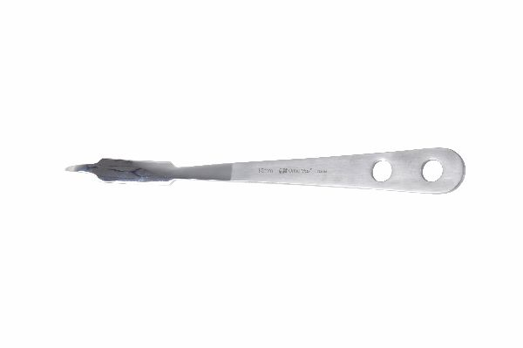
Function
The curved, spade-shaped blade tip is introduced subperiosteally or into the fascial plane adjacent to bone and levered against the cortex. The blade acts as a fulcrum, pushing surrounding soft tissue away from the bone surface while the handle keeps the surgeon's hand outside the operative field for unobstructed working.
Advantages
Universal Application: Available in micro, standard and large sizes, the Hohmann family is applicable in every body region from feline metacarpal fractures to equine cannon bone surgery, making it the single most versatile bone-adjacent retractor in veterinary orthopaedics.
Self-Sustaining Retraction: Once the blade is levered against cortex, body weight and tissue pressure keep it in position without requiring an assistant to hold it, freeing all team members for active tasks during implant application.
FAQ
Q: What size Hohmann is used for stifle surgery in a 30 kg dog?
A: A medium Hohmann with a 20–25 mm wide blade is appropriate; the blade width should be matched to the bone circumference to achieve stable contact without slipping during retraction.
Q: How is a Hohmann retractor positioned to protect the sciatic nerve?
A: The blade is placed on the lateral femoral cortex for femoral plating; it must remain on bone — never behind soft tissue where the sciatic nerve may be inadvertently compressed between blade and periosteum.

ORTHOPAEDIC INSTRUMENTS
Bone Levers & Retractors
Kilner Retractor Double Ended
Intended Use
The Kilner double-ended retractor is a versatile handheld retraction instrument used in veterinary orthopaedic and soft tissue surgery to retract wound edges at variable depths. Its two differently sized ends allow the scrub staff to select the optimal retraction profile for each layer of the wound without instrument change. | 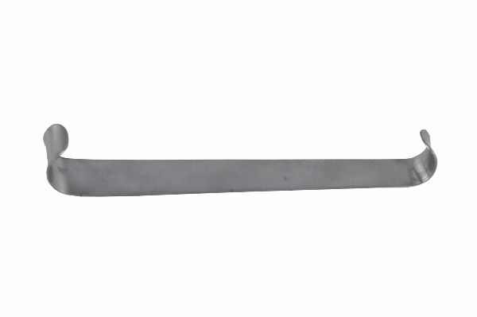
Function
An S-shaped handle connects two working blades of different dimensions. The larger blade provides broad superficial retraction while the smaller, deeper blade retracts in narrow wound depths. The ergonomic handle allows single-handed retraction while the other hand continues dissection or implant insertion.
Advantages
Adaptable Two-Layer Retraction: One instrument serves both the superficial fascial and deep muscular layers of orthopaedic approaches, reducing the frequency of instrument changes during progressive wound deepening and streamlining operative flow.
Smooth Non-Traumatic Blades: Rounded blade edges spread retraction force over the tissue width without cutting, making Kilner retractors particularly suitable in young animals with fragile investing fascial layers.
FAQ
Q: When is the double-ended Kilner preferred over a Langenbeck retractor?
A: The Kilner's two ends provide more flexibility in adapting to wound depth than the fixed single-blade Langenbeck; the Kilner is preferred when the wound depth changes frequently during approach layering.
Q: Can the Kilner retractor be used for spinal approaches?
A: Yes, the smaller end is useful for retracting paraspinal musculature in dorsal laminectomy approaches in small dogs and cats where a full-sized Langenbeck would obstruct instrument access.

ORTHOPAEDIC INSTRUMENTS
Bone Levers & Retractors
Kilner Skin Retractor
Intended Use
The Kilner skin retractor is a single-blade, single-function retraction instrument designed specifically for skin and subcutaneous tissue retraction in veterinary surgical approaches. Its simple, lightweight design makes it easy for assistants to hold for extended periods without fatigue. | 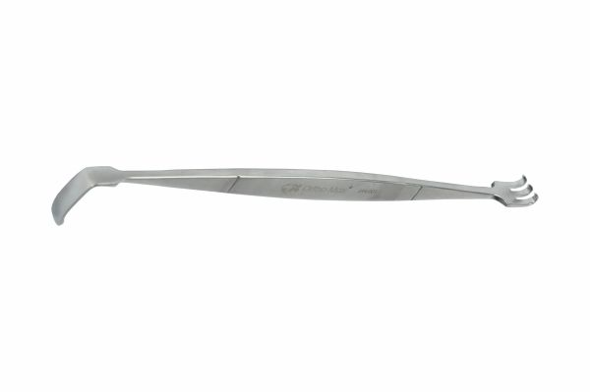
Function
A smooth, slightly curved single blade is attached to a slim handle at a convenient retraction angle. The blade is hooked under the skin wound margin and drawn outward to expose the subcutaneous layer for dissection. The lightweight construction reduces assistant hand fatigue during lengthy orthopaedic procedures.
Advantages
Lightweight Sustained Retraction: The slim instrument weight minimises assistant fatigue during prolonged retraction in complex fracture repairs, where skin retraction must be maintained for 60–120 minutes without interruption.
Atraumatic Skin Edge: The smooth, rounded blade tip does not cut skin during sustained retraction, preventing wound margin necrosis that can complicate skin closure and lead to incisional dehiscence in the post-operative period.
FAQ
Q: How does the Kilner skin retractor differ from the double-ended model?
A: The single-blade version is lighter and simpler, dedicated to skin retraction only; the double-ended model adapts to two depths, making it more versatile but slightly heavier.
Q: Is a dedicated skin retractor needed if a Langenbeck is already available?
A: In deep wounds the Langenbeck doubles as both skin and deep retractor; for purely skin-level retraction in superficial incisions, the lighter Kilner is ergonomically superior.

ORTHOPAEDIC INSTRUMENTS
Bone Levers & Retractors
Right Angle Retractor – Langenbeck
Intended Use
The Langenbeck right-angle retractor is the standard instrument for deep wound retraction in veterinary orthopaedic surgery. Its right-angled blade geometry allows deep wound exposure by hooking under soft tissue and holding it out of the operative field perpendicular to the wound axis. | 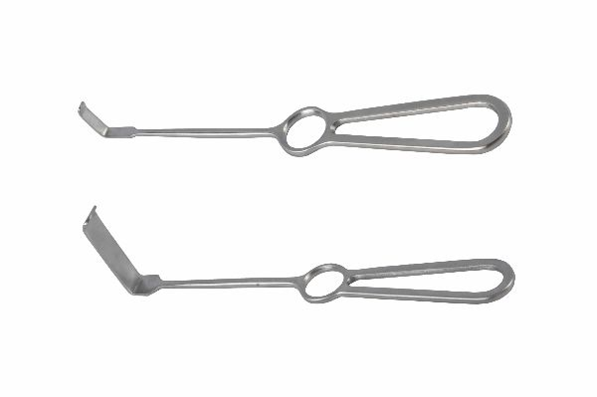
Function
The L-shaped blade is introduced into the wound depth and the angle of the blade engages under the deep tissue mass, which is then displaced by pulling the handle. The right-angle creates a stable retraction force that does not require the assistant to tilt or angle the instrument awkwardly to maintain tissue displacement.
Advantages
Deep Wound Access: The right-angle blade geometry provides access to wound depths of 5–10 cm in large breed dogs, exposing the deep femoral, humeral and spinal structures without requiring additional depth retractors.
Stable Perpendicular Retraction: The 90° blade ensures retraction force acts perpendicular to the wound, preventing the tissue slippage that occurs with shallower-angled blades when the assistant relaxes hand position momentarily.
FAQ
Q: What blade widths are available for the Langenbeck retractor?
A: Widths range from 12 mm (cat and small dog spinal surgery) to 40 mm (large breed femoral plating), with 20 mm and 25 mm being the most commonly used sizes in general small animal orthopaedics.
Q: Should the blade be smooth or serrated?
A: Smooth blades are standard for muscle retraction; serrated blades provide grip on fibrous fascia and periosteum but increase tissue trauma in delicate structures adjacent to neurovascular bundles.

ORTHOPAEDIC INSTRUMENTS
Bone Levers & Retractors
Self-Retaining Mastoid Retractor
Intended Use
The self-retaining mastoid retractor is a spring-loaded instrument used to maintain wound opening in veterinary orthopaedic and ENT procedures without manual assistance. Originally designed for mastoid surgery, it is also used in small animal skull, temporal bone and narrow wound approaches requiring sustained hands-free retraction. | 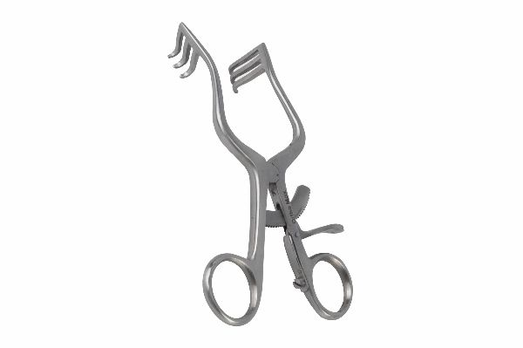
Function
Two or three angled blades spread outward from a central spring mechanism. When introduced into the wound and released, spring tension spreads the blades apart, retracting the wound edges simultaneously. A ratchet maintains the spread position, allowing both the surgeon and assistant to work with both hands free.
Advantages
Hands-Free Wound Maintenance: The self-retaining spring mechanism holds wound edges apart without a dedicated assistant, particularly valuable in single-surgeon practices or when all available hands are occupied with implant manipulation.
Adjustable Spread Width: A ratchet mechanism allows the spread width to be set at multiple positions and adjusted during the procedure as deeper structures require narrower or wider retraction of successive tissue layers.
FAQ
Q: Can the mastoid retractor be used for spinal surgery in dogs?
A: Yes, particularly for narrow dorsal laminectomy approaches in small dogs and cats where its compact blade spread maintains adequate exposure without the bulk of larger frame retractors.
Q: How is tissue damage minimised with self-retaining retractors?
A: Limit continuous retraction to 20–30 minute intervals, release and reposition the retractor to restore perfusion, and moisten exposed deep tissue with saline gauze to prevent desiccation.

ORTHOPAEDIC INSTRUMENTS
Bone Levers & Retractors
Self-Retaining Skin Retractor – Alm's
Intended Use
The Alm's self-retaining skin retractor is a spring-loaded device used to maintain skin wound margins in the retracted position without manual assistance during veterinary surgical procedures. The fine, multi-tined blades grip the dermis securely while the spring maintains continuous outward tension throughout the procedure. | [Missing: Self Retaining Skin Retractor - Alm's.jpg]
Function
Two opposing combs of fine sharp tines are attached to spring-loaded arms. When the arms are spread over the wound and released, the tines engage the dermal layer on each side and spring tension holds the wound open. The compact design allows placement in small wounds without obstructing deep instrument access.
Advantages
Sustained Skin Edge Exposure: The spring maintains consistent retraction tension as wound anatomy changes during deepening, preventing the progressive skin edge creep that occurs with manual retractors when assistant attention fluctuates.
Compact Wound Compatibility: The slim tine design occupies minimal wound space, allowing deep retractors and long-handled instruments to be used simultaneously without collision, essential in deep orthopaedic approaches through small skin incisions.
FAQ
Q: Do the fine tines damage skin edges?
A: Fine sharp tines cause minimal dermal trauma if the wound margin is adequate; they should not be placed under excessive tension on thin or ischaemic skin where tine pressure could cause marginal necrosis.
Q: Can Alm's retractors be sterilised in pouches?
A: Yes. The spring mechanism is fully autoclavable; sterilise in an open position so steam reaches all spring coil surfaces for complete sterilisation assurance.

